Copy User Data.exe – User Data Migration Tool Author – Yun Lee

Contents

1. Graphical User Interface 1

2. About Copy User Data 1

3. Installation 1

4. How to Use it 2

5. FAQ 2

# Graphical User Interface

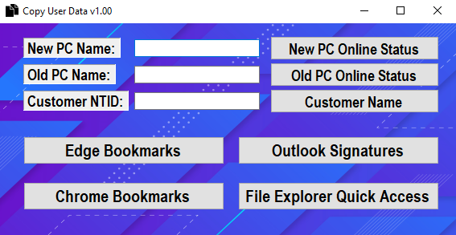

# About Copy User Data

Copy User Data is a user data migration tool that enables transferring personal user data such as bookmarks from Edge and/or Chrome, Outlook signatures, and Quick Access in File Explorer from ‘AppData’ folder in C: using a network path. It could be used when a user upgrades or loans a pc for temporary use.

# Installation

1. Code is already compiled via Visual Studio.
2. CopyUserData.exe is located at \\in1\opu\IT\YunL-Code\CopyUserData.exe

# How to Use it

1. Fields: New PC Name, Old PC Name, and Customer NTID must be filled with the correct entry.
2. Confirm the online status of the New PC by clicking ‘New PC Online Status’
3. Confirm the online status of the Old PC by clicking ‘Old PC Online Status’
4. Confirm customer name by clicking ‘Customer Name’
5. To Transfer Edge Bookmarks, click ‘Edge Bookmarks’ button.
6. To Transfer Chrome Bookmarks, click ‘Chrome Bookmarks’ button.
7. To Transfer Outlook Signatures, click ‘Outlook Signatures’ button.
8. To Transfer Quick Access in File Explorer, click ‘File Explorer Quick Access’ button.

# FAQ

* Does pc need to stay online?
  + Yes, it is using a network path: \\hostname or ip address\\c$\users\customer ntid\AppData. Both new pc and old pc must be online. Otherwise, you will get an error prompt as below.

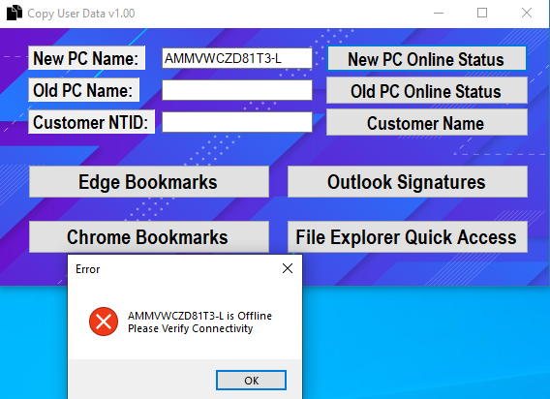

* Does it filter invalid pc names?
  + Yes, it uses ping class from .net. It will filter invalid hostname entry.

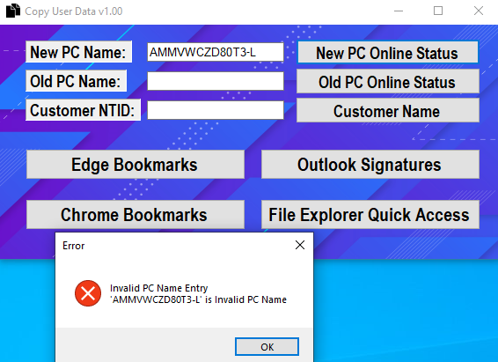

* Does it filter invalid NTID?
  + Yes, it queries user data from Active Directory

